Eco Essential
Eco Essentials Data Warehousing
Enterprise Data Warehouse Design

- Draft a bus matrix outlining key business processes.

Business Process | Dimensions | Fact Table
Sales Process | Date, Customer, Product, Promotional Campaign, Order | Fact_Sales
Marketing Email Conversion Process | Date, Customer, Email Campaign, Event Type | Fact_Email_Marketing_Events

- Star Schema Creation
- Select the business process

Sales Process: Tracking online product purchases and performance trends.

Marketing Email Conversion Process: Tracking marketing emails sent to customers and their engagement or conversion outcomes.

- Declare the Grain
Sales Process Grain: Each record in the sales fact table represents a single line item within an order.

Marketing Email Conversion Grain: Each record in the marketing fact table represents a single email event sent to or interacted with by a customer.

- Identify Dimensions

Sales Process Dimensions:

dim_customer: Contains customer information such as customer_ID, name, DOB, phone, email, address, city, state, zip.

dim_product: Includes product details such as product ID, name, type, supplier and price.

dim_promotional_campaign: Stores campaign ID, name, and discount amount.

dim_date: Captures timestamps for orders, allowing time-based analysis (day, month, year, quarter).

dim_order: Contains order-level attributes such as order ID and timestamp and payment type

Marketing Email Conversion Dimensions:

dim_customer: Shared across both processes, representing the same individuals.

dim_email_campaign: Contains email campaign attributes such as campaign ID, campaign name, and email ID.

dim_event_type: Defines the type of event, such as “Email Sent,” and “Email Opened” .

dim_date: Represents both the send date and event timestamp.

- Identify Facts
Fact Table for Sales Process: fact_sales
Foreign Keys: customer_id, product_id, campaign_id, date_id, order_id
Measures: quantity, total_sales

Fact Table for Marketing Email Conversion: fact_email_marketing_events
Foreign Keys: customer_id, campaign_id, event_type_id, date_id
Measures: email_sent_count, email_open_count, conversion_flag

- Now combine the two separate star schemas into one enterprise data warehouse.
The Sales and Marketing data models wil be connected through the dim_customer and dim_date tables. This way analysts can correlate marketing activity (such as email opens or clicks) with subsequent purchases in the sales system.

- Identify conformed dimensions to ensure consistency across schemas. You may want to highlight the conformed dimensions.

dim_customer.
dim_date

- Submit (a legible) screenshot of your dimensional model in LucidChart. (Please label your objects with either dim_ or fact_)
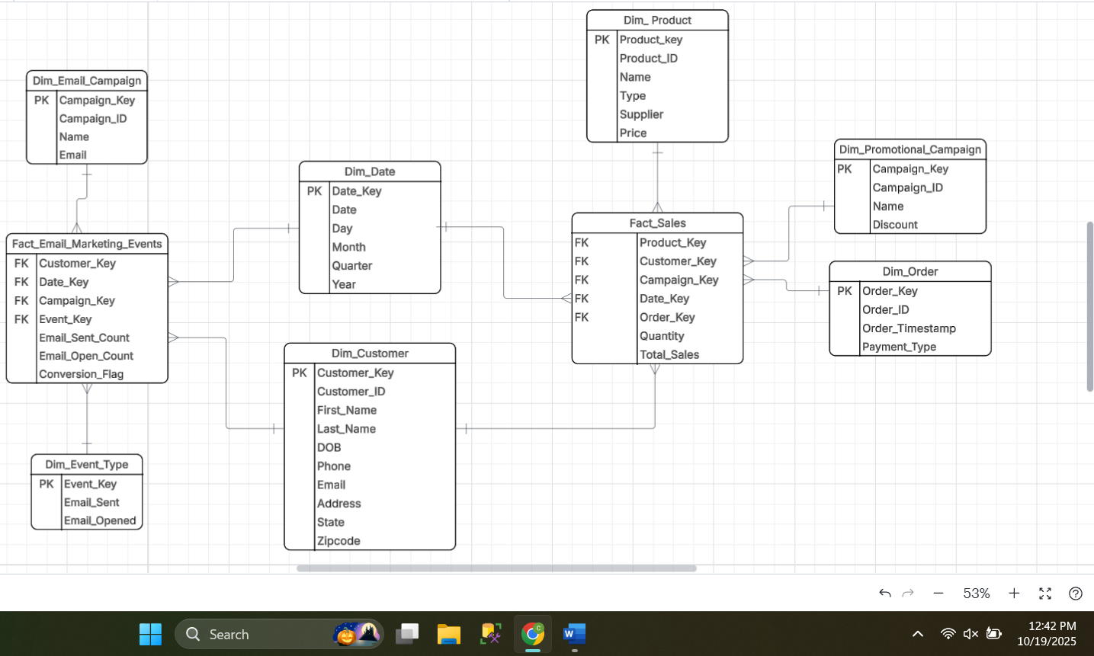

Extract, Load, and Transform

While reflecting back on the first deliverable I decided to drop email campaign and event type tables. After loading the data, I changed the table columns according to the data I received.
The first thing I did next was create my src.yml.
_src_ecoessentials.yml
Code:
version: 2

sources:
- name: ecoessentials_transactional
database: CHRISTIANKERNS
schema: ECOESSENTIALS_TRANSACTIONAL_DB
tables:
- name: customer
- name: orders
identifier: "\"ORDER\""
- name: order_line
- name: product
- name: promotional_campaign

- name: ecoessentials_marketing
database: CHRISTIANKERNS
schema: ECOESSENTIALS_MARKETING_EMAILS
tables:
- name: marketing_emails

(This was a challenge in fixing later on, due to the word ORDER causing errors while creating dim_order. This was the solution I figured out.)

Then started to create my dim tables first with Dim_Customer
Code:
{{ config(materialized = 'table', schema = 'ecoessentials_dw') }}

SELECT
CUSTOMER_ID AS customer_key,
CUSTOMER_ID,
CUSTOMER_FIRST_NAME AS first_name,
CUSTOMER_LAST_NAME AS last_name,
CUSTOMER_ADDRESS AS address,
CUSTOMER_CITY AS city,
CUSTOMER_STATE AS state,
CUSTOMER_ZIP AS zip,
CUSTOMER_COUNTRY AS country,
CUSTOMER_PHONE AS phone
FROM {{ source('ecoessentials_transactional', 'customer') }}

Dim_Product
{{ config(materialized = 'table', schema = 'ecoessentials_dw') }}

SELECT
PRODUCT_ID AS product_key,
PRODUCT_ID,
PRODUCT_NAME,
PRODUCT_TYPE,
PRICE
FROM {{ source('ecoessentials_transactional', 'product') }}

Dim_Order
{{ config(
materialized = 'table',
schema = 'ecoessentials_dw'
) }}

SELECT
ORDER_ID AS order_key,
ORDER_ID,
CUSTOMER_ID,
ORDER_TIMESTAMP
FROM {{ source('ecoessentials_transactional', 'orders') }}

Dim_Campaign
{{ config(materialized = 'table', schema = 'ecoessentials_dw') }}

SELECT
CAMPAIGN_ID AS campaign_key,
CAMPAIGN_ID,
CAMPAIGN_NAME,
CAMPAIGN_DISCOUNT
FROM {{ source('ecoessentials_transactional', 'promotional_campaign') }}

Dim_Date
{{ config(materialized = 'table', schema = 'ecoessentials_dw') }}

WITH cte_date AS (
{{ dbt_date.get_date_dimension("1990-01-01", "2050-12-31") }}
)
SELECT
date_day AS date_key,
date_day,
day_of_week,
month_of_year,
month_name,
quarter_of_year,
year_number
FROM cte_date

Then I started my facts
Fact_Sales
{{ config(materialized='table', schema='ecoessentials_dw') }}

SELECT
p.product_key,
c.customer_key,
cm.campaign_key,
d.date_key,
o.order_key,
ol.quantity,
(ol.quantity * ol.price_after_discount) AS total_sales
FROM {{ source('ecoessentials_transactional', 'order_line') }} ol
INNER JOIN {{ ref('dim_order') }} o
ON ol.ORDER_ID = o.ORDER_ID
INNER JOIN {{ ref('dim_product') }} p
ON ol.PRODUCT_ID = p.PRODUCT_ID
INNER JOIN {{ ref('dim_customer') }} c
ON o.CUSTOMER_ID = c.CUSTOMER_ID
LEFT JOIN {{ ref('dim_campaign') }} cm
ON ol.CAMPAIGN_ID = cm.CAMPAIGN_ID
INNER JOIN {{ ref('dim_date') }} d
ON d.date_key = CAST(o.ORDER_TIMESTAMP AS DATE)

Fact_Marketing
{{ config(materialized = 'table', schema = 'ecoessentials_dw') }}

WITH marketing_base AS (
SELECT
e.emaileventid AS email_event_key,
e.emailid,
e.campaignid,
e.subscriberid AS customer_id,
e.eventtype,
e.eventtimestamp,
CASE
WHEN LOWER(e.eventtype) LIKE '%open%' THEN 1 ELSE 0
END AS email_open_flag,
CASE
WHEN LOWER(e.eventtype) LIKE '%sent%' THEN 1 ELSE 0
END AS email_sent_flag
FROM {{ source('ecoessentials_marketing', 'marketing_emails') }} e
),

customer_conversion AS (
SELECT
c.customer_key,
CASE
WHEN COUNT(o.order_id) > 0 THEN 1
ELSE 0
END AS conversion_flag
FROM {{ ref('dim_customer') }} c
LEFT JOIN {{ source('ecoessentials_transactional', 'orders') }} o
ON o.customer_id = c.customer_key
GROUP BY c.customer_key
)

SELECT
f.email_event_key,
f.emailid,
f.campaignid,
f.customer_id,
d.date_key,
d.date_day,
d.month_of_year,
d.year_number,
f.email_open_flag,
f.email_sent_flag,
cc.conversion_flag
FROM marketing_base f
LEFT JOIN {{ ref('dim_customer') }} c
ON f.customer_id = c.customer_key
LEFT JOIN {{ ref('dim_date') }} d
ON DATE(f.eventtimestamp) = d.date_day
LEFT JOIN customer_conversion cc
ON f.customer_id = cc.customer_key

Data warehouse populated in Snowflake

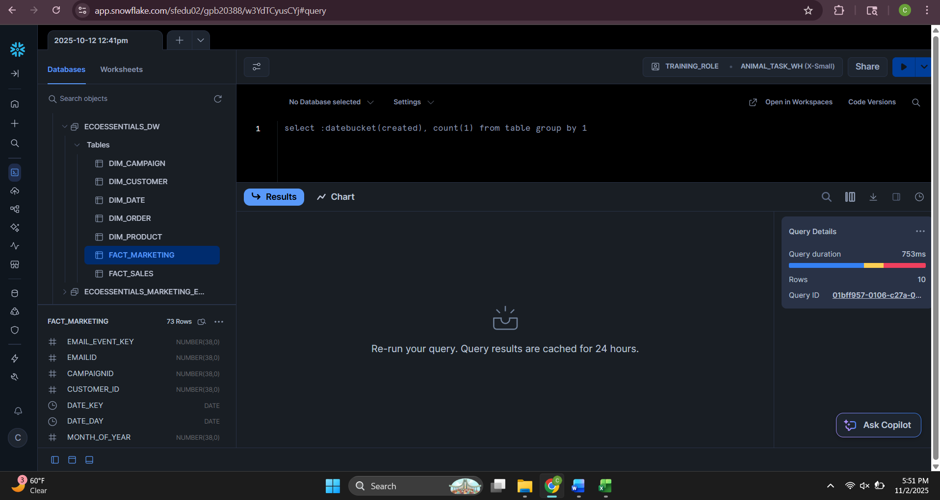
Business Question 1
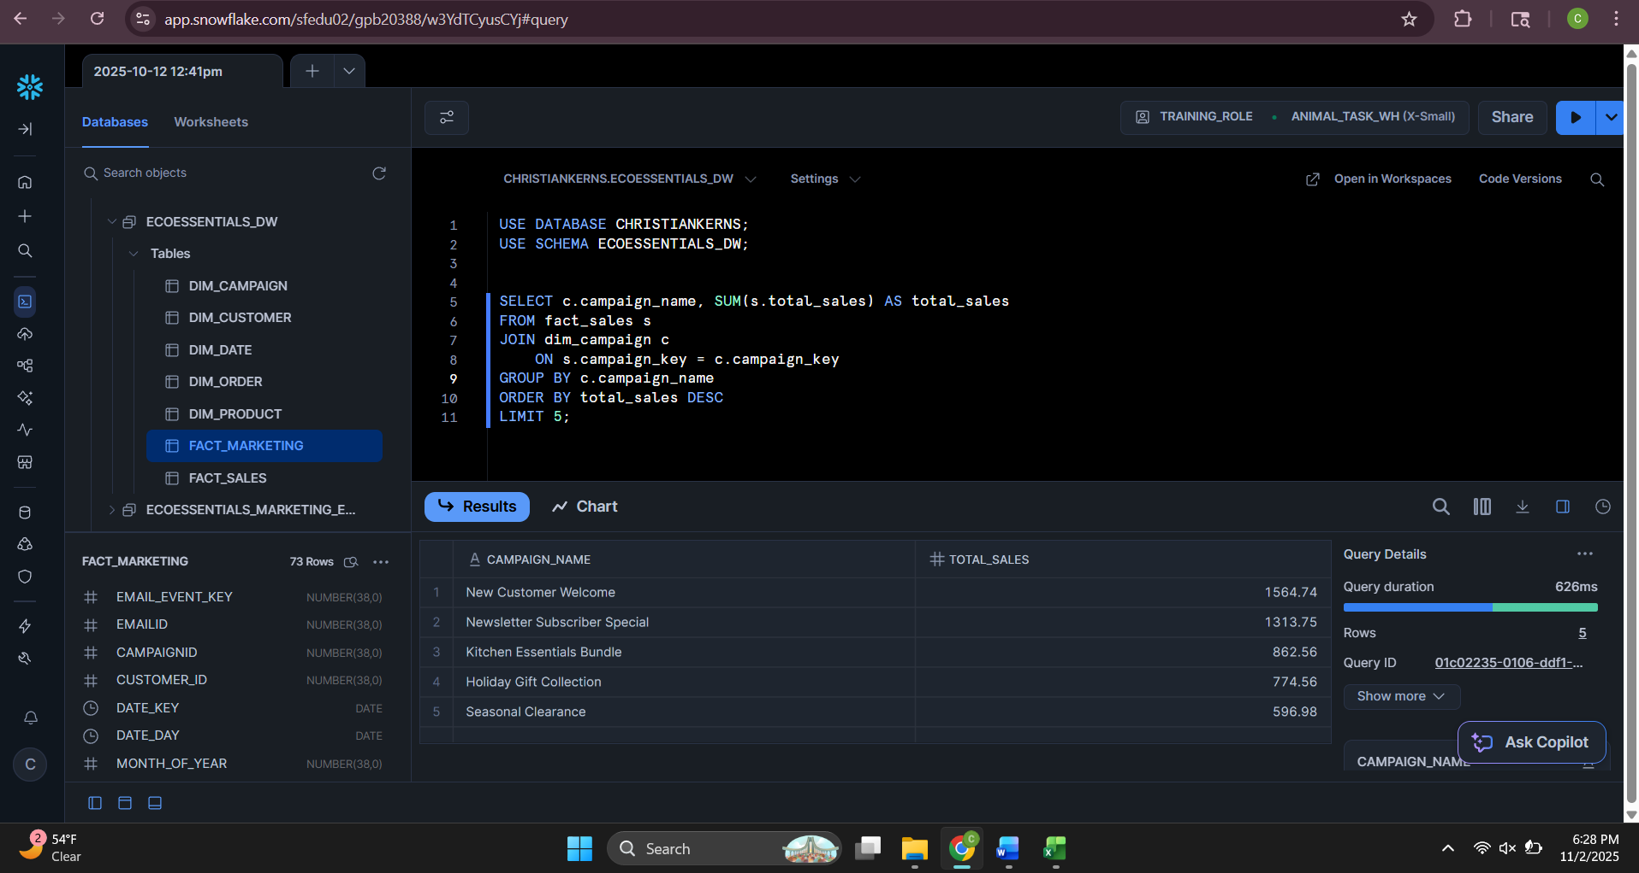
Which promotional campaign generated the most total sales?
Which customers have spent the most money overall?
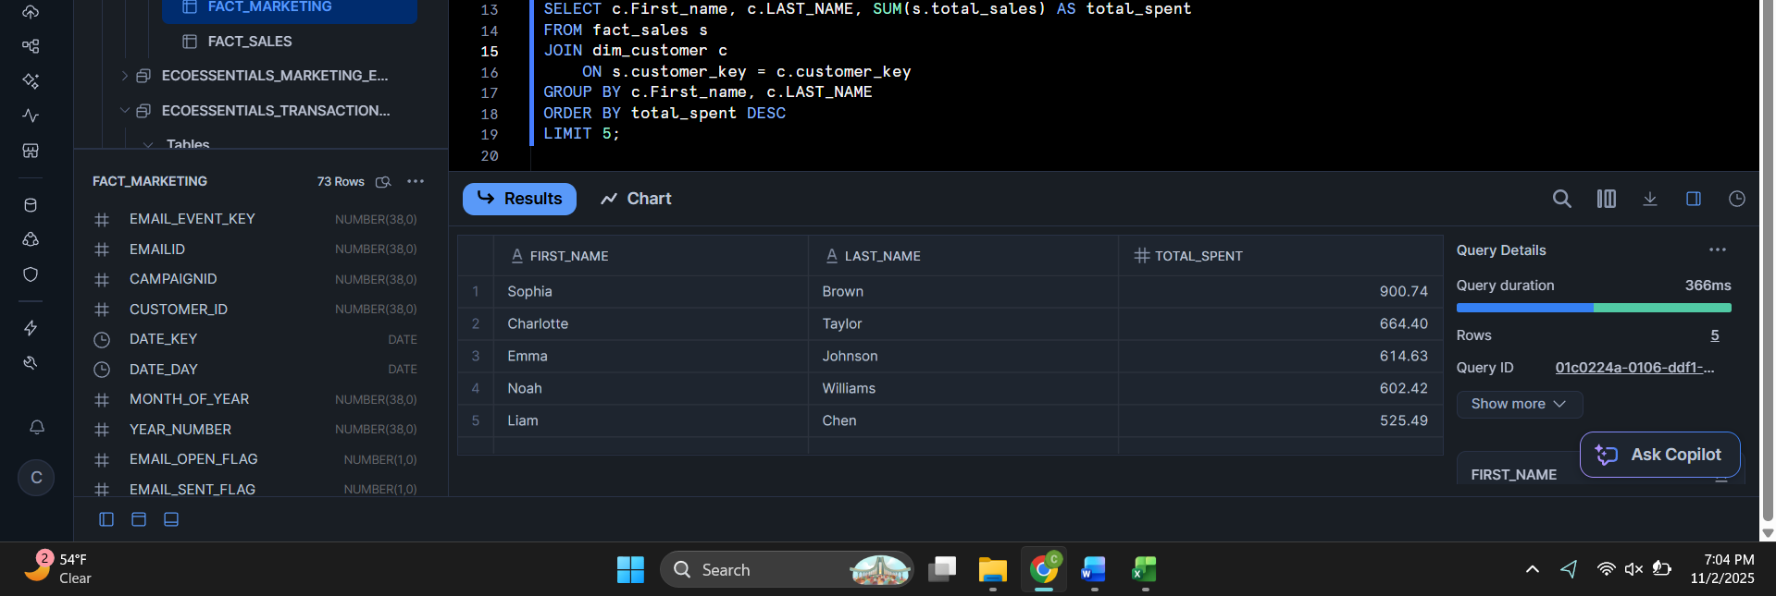

Which month had the highest total sales?
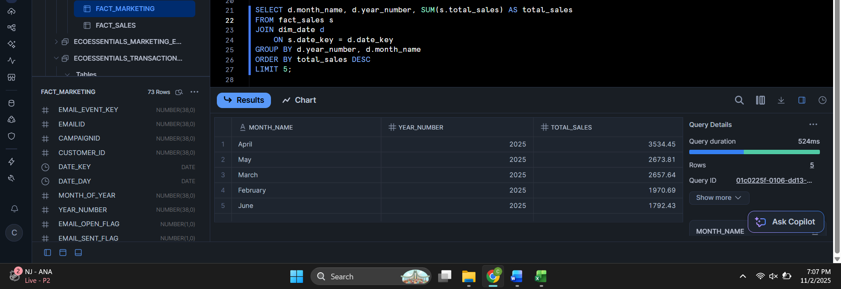

Testing & Scheduling
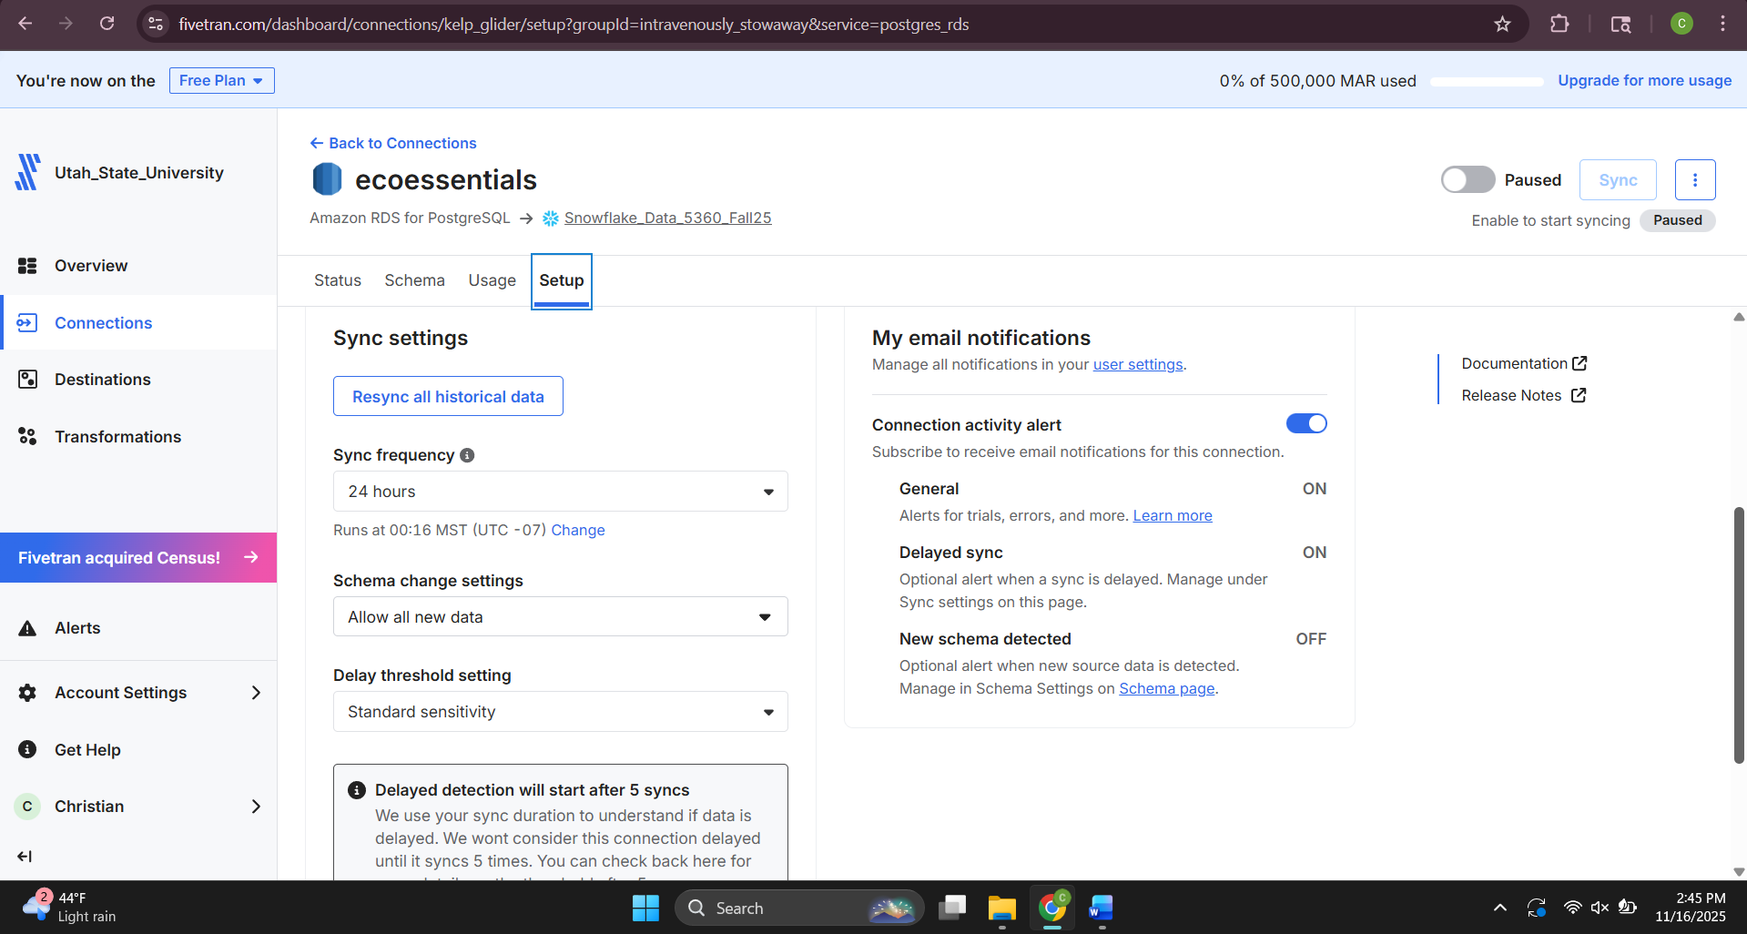

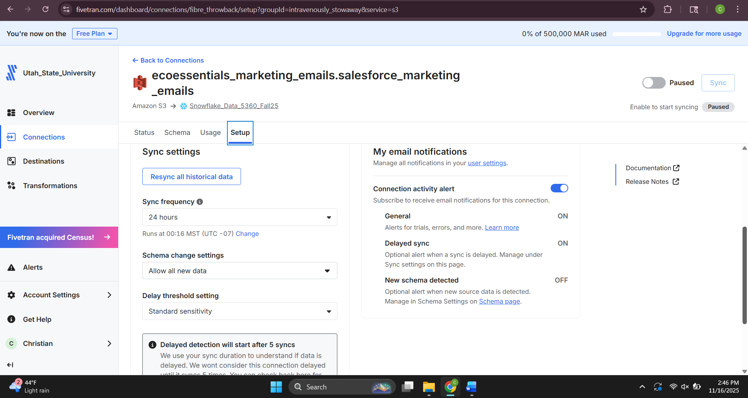

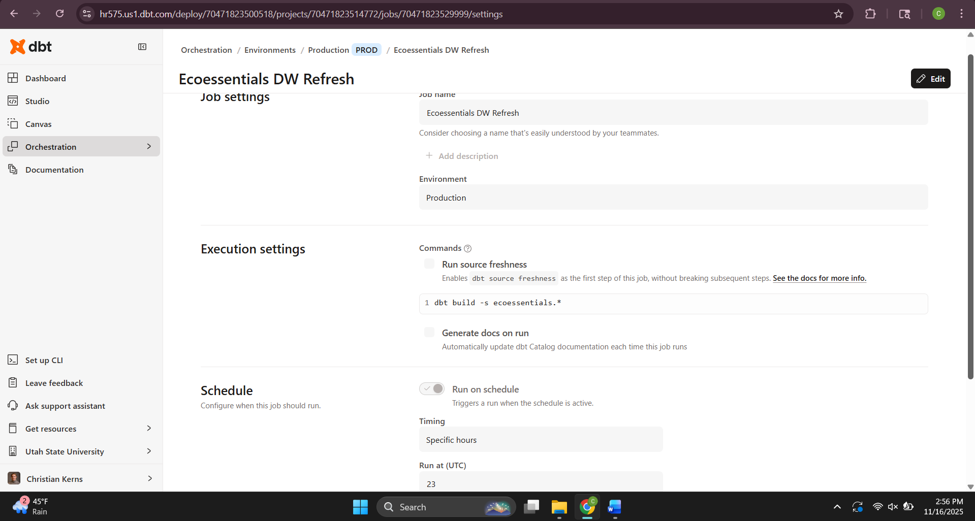

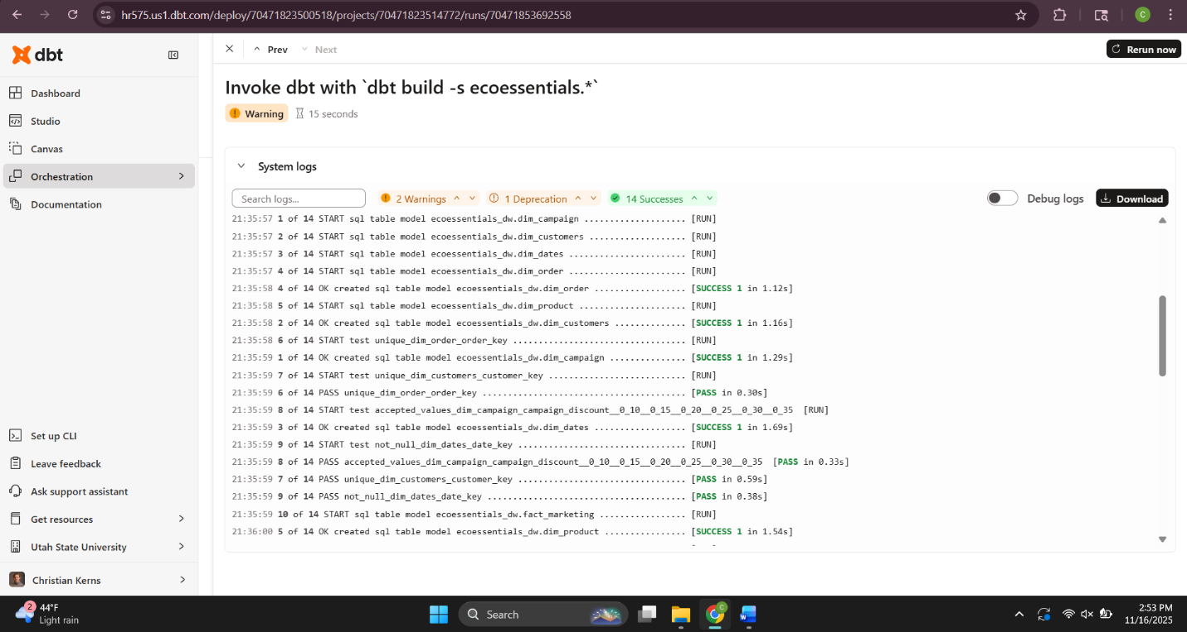

Completed project

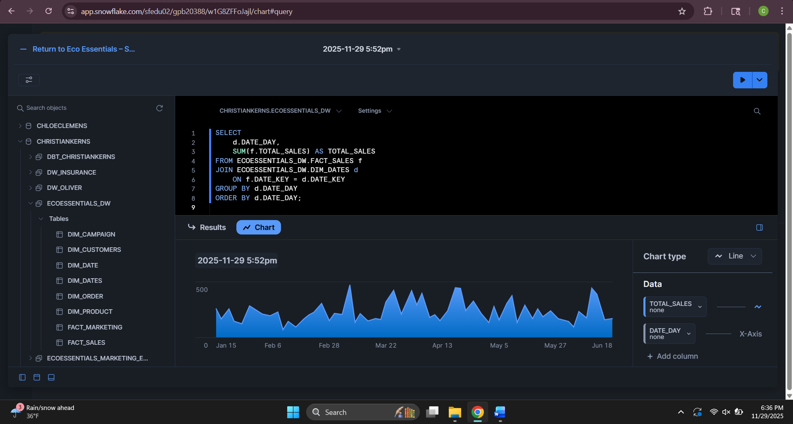
Sales Trend

Email Funnel

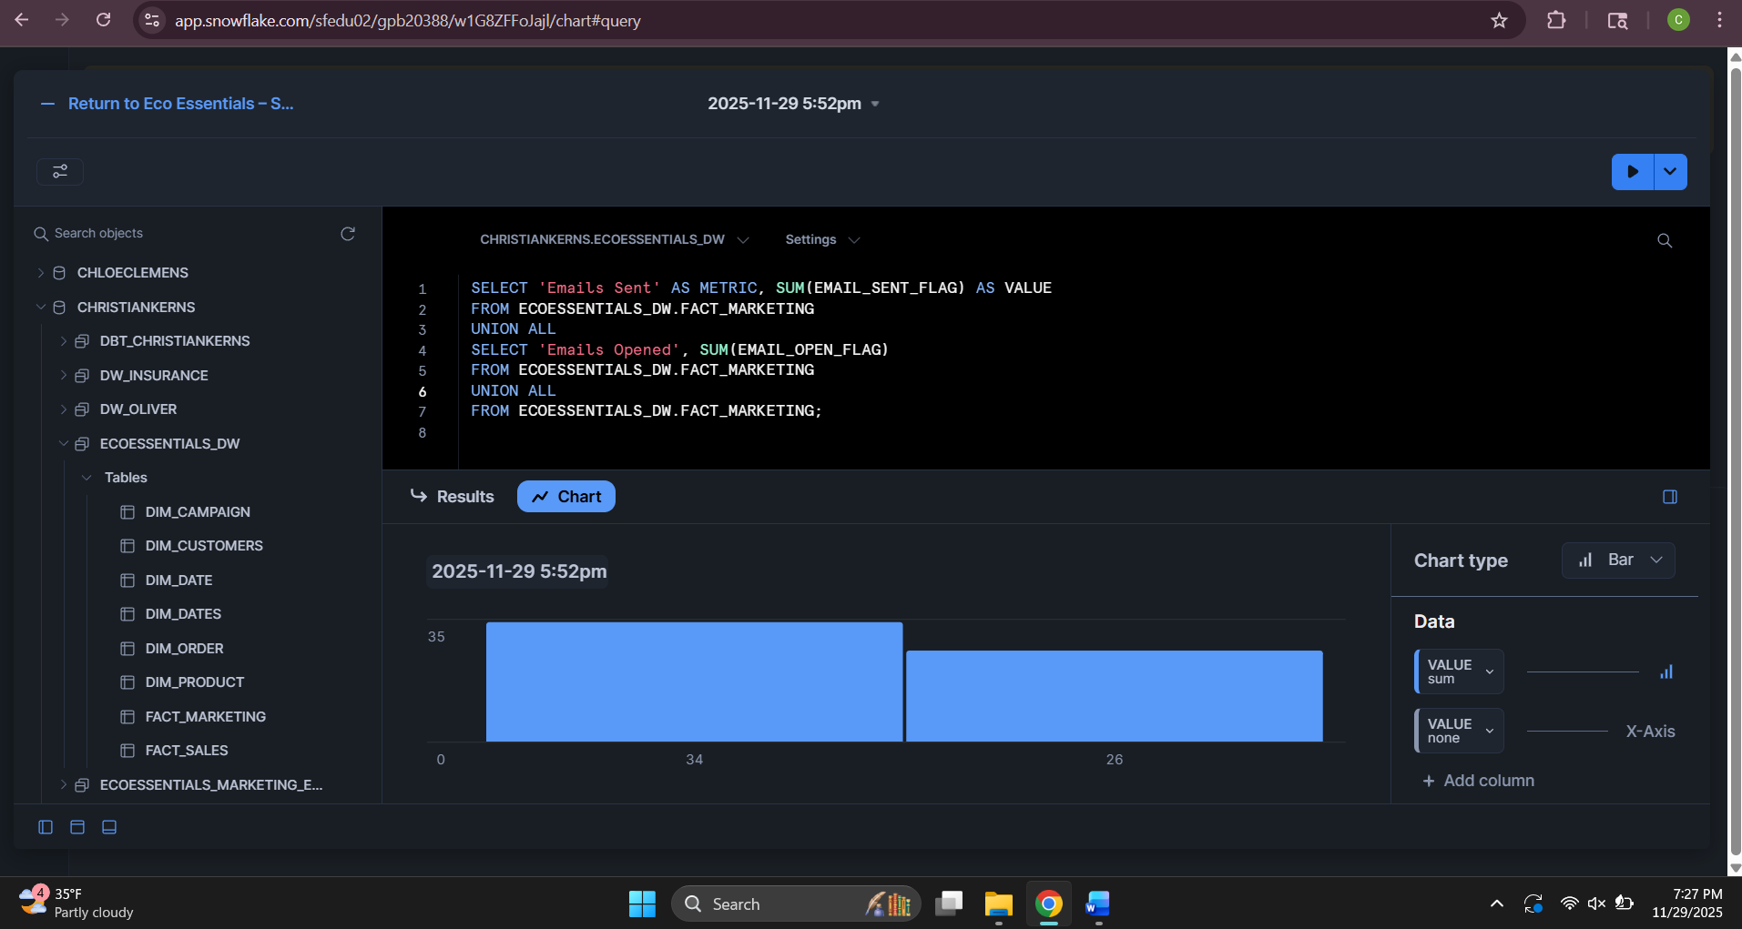

Campaign Performance

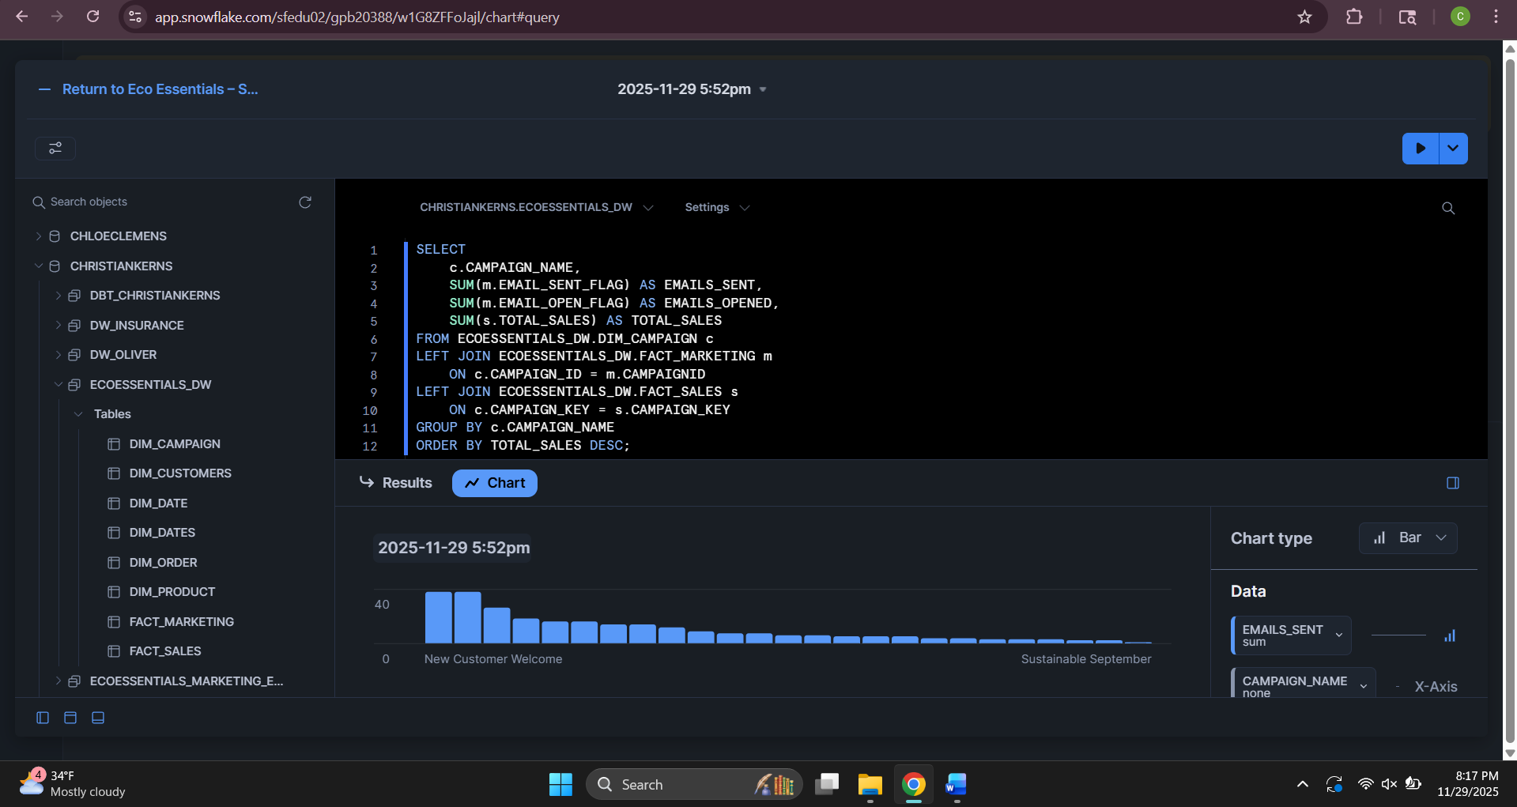

Explanation
Here we can see how Eco Essentials is doing with both sales and marketing. The sales trend shows how sales move up and down over time, so it’s easy to spot when things are busy or slow. The email funnel breaks down how many emails were sent and how many people actually opened them, which helps show whether the marketing efforts are getting any attention. The campaign performance chart compares each campaign’s email activity with the sales connected to it, making it clear which campaigns are actually helping bring in money. Altogether, the dashboard gives a quick, easy-to-understand picture of what’s working and where there might be room to improve

